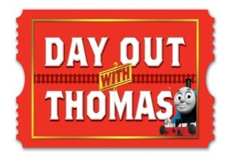
DOWT– Gembrook Station
Position Descriptions: Crossing Supervisors
Shift: 8:30am – 4pm Note: The site open to public: 9am – 3:30pm
Location: Supervisors will be situated at both the Down End and Up End crossings of the Heritage Platform on either side of the track.
Role responsibilities:
Prior to 9:30am; please assist as per the Events Supervisor on the day.

From 9:30am – 3pm; manage the crossing.
The purpose of this role is to ensure the crossing is closed and tracks are clear before any train movement happens in the yard.
- Communication with Signalman is essential in this role.
  - Please refer to the train operations run sheet in the volunteer manual to identify the times of train movement.
- The closing the Heritage Platform / Crossing at all times unless open for boarding/disembarking.
  - Heritage Platform / Crossing is only open for:
    - 20minutes prior to train departure
    - 10 minutes after the train arrives.
- As passengers walk through the crossing, visually check which colour wristband the passengers have in accordance to the departing trains.
10:00 Thomas shuttle – Blue wristband
11:20 Thomas shuttle – Red wristband
12:40 Thomas shuttle – Yellow wristband
2:00 Thomas shuttle – White wristband

- After the train ride, patrons will be directed to both ends of the Heritage Platform to cross the railway track and return to the other activities on offer.
  - Those passengers who are collecting prams will be advised to utilise the UP end crossing of the platform.
- The role is also required to act as information points for patrons – please know where toilets, first aid, exit and activities are as per the site map.

Items required:
- Available at Sign In:
  - Hi-Vis Vest
  - Volunteer manual – which includes train operations run sheet and site map.
- There will be post and chains available to assist with securing the crossing area.
Breaks are to be taken during quiet times – please inform others when exiting your role.
On conclusion of your shift – BRIGHT IDEAS FORMS are available for feedback and suggestions on improving this position description and DOWT event.
- THANK YOU -

