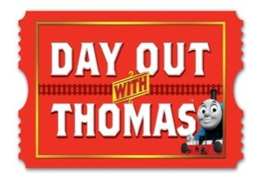
DOWT – Gembrook Station
Position Descriptions: Conductors / Passenger Supervisor
Refer to Jean’s new position re: 1 conductor to 8 carriages etc

Shift: 8:00am for briefing–4:00pm
Note: The site open to public: 9am – 3:30pm
Location: Heritage Platform from 9:30am-3:00pm
Note: The Heritage Platform is closed for passenger access at all times unless open for boarding.
(20minutes prior to departure)
Before 9:30am – Role responsibilities:
Assist as per the Event Managers discretion
- Assist with queue management at the Site Entry.
- Welcome passengers – assist with directional questions.

From 9:35am - Role responsibilities:
- Standard conductor responsibilities on the Heritage Platform.
- Assist passengers boarding – no earlier than 20 minutes prior to train departure
- The role is also required to act as information points for patrons.
- As per PBR carriage policy – prams are not permitted on the carriages so please inform patrons to place prams in the Pram Bay (#10).
- Please inform passengers to place bags under their seats and encourage them to dangle their legs (weather permitting).
- If required, once Thomas shuttle returns to Heritage Platform, please monitor UP end Heritage Platform crossing to ensure any passengers using the crossing are doing so safely.

Ticket notes: Conductors do not need to specifically check tickets as all passengers have received a wristband upon entry. Please monitor the wristbands to ensure patrons are travelling on the correct train.

10:00 Thomas shuttle – Blue wristband
11:20 Thomas shuttle – Red wristband
12:40 Thomas shuttle – Yellow wristband
2:00 Thomas shuttle – White wristband

Please refer all ‘missed the train’ enquiries to the Station Master
More info: The Event Supervisor will brief the Fat Controller, Dan the Driver, Shunter Charlie along with the conductor on the days requirements.
Note from Jean: Please ensure the Wheelchair car is properly closed/ locked
On conclusion of your shift – BRIGHT IDEAS FORMS are available for feedback and suggestions on improving this position description and DOWT event.
- THANK YOU -

